My name is:

Lesson Five

Copy and Paste

Watch your teacher demonstrate how to copy and paste. Talk over the steps with a partner before you begin.
Practice One: Read the questions below. The auxiliary verbs are missing. You will copy and paste the verbs inside the questions. Follow these steps:

- Scroll down. Read each question, think and decide which auxiliary verb you need.

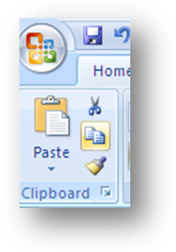
- Move the cursor to the middle of the auxiliary verb. Double click to select.

- Move your mouse to the copy icon in the upper left corner. Click it one time and the computer copies it for you. (You won’t see the copy yet.)

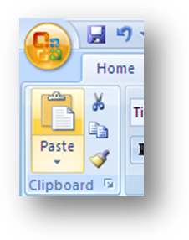
- Move the cursor back to the question. Click one time at the place you want to put the auxiliary verb.

- Move your mouse up to the corner again. Click Paste. Watch! The computer will put the verb in the question for you. You don’t need to type the verb!

- Repeat for the other questions.

Remember:
1) Select. 2) Choose Copy.
3) Move your cursor and click. 4) Choose paste.

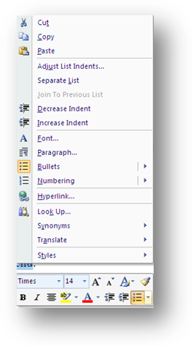
Extra Lesson: You can copy paste with your mouse. It’s easier for some people.

- Select the text with a double click.
- Right click with your mouse. You will see a menu like this one.
- Choose copy. The menu will close.
- Move your mouse and move your cursor. Click.
- Right click again to open the menu. Choose paste. You are finished!

Auxiliary Verbs

do does did am is
are was were will can
have has should could would

Questions

- When you begin to work with computers?
- Who your first computer teacher?
- What you understand about computers a few years ago?
- What easy for you to do on a computer recently?
- When you buy a computer?
- Why you want to learn about computers?
- How you use a computer in your life?
- What you do on a computer easily?
- What our teacher help us learn in this class?
- When children begin to work with computers?

What will you do
with a computer?
What should I do?
Practice Two: Check your grammar with a classmate. Ask and answer the questions from Practice One.

Practice Three: Read the scrambled sentences below about using a computer. They are not in order. Copy and paste the words to make five English sentences.

- Find the first word. (Look for capital letter!)
- Copy the first word. Paste it under the scrambled sentence.
- Copy the next word. Paste it under the scrambled sentence.
- Continue. When you finish, you will see the scrambled sentence and the correct sentence under it. Don’t forget any words! Count to check your work. Remember to check punctuation.
- Check with a partner.

Five Scrambled Sentences

(1) fonts several have about had We questions.

(2) again document have save forgotten to I my.

(3) floppy under grammar notebook was disk My your.

(4) letter yesterday really printed the business I you liked.

(5) last confused have absent I feeling I week today because been was.

Save and print your work.

